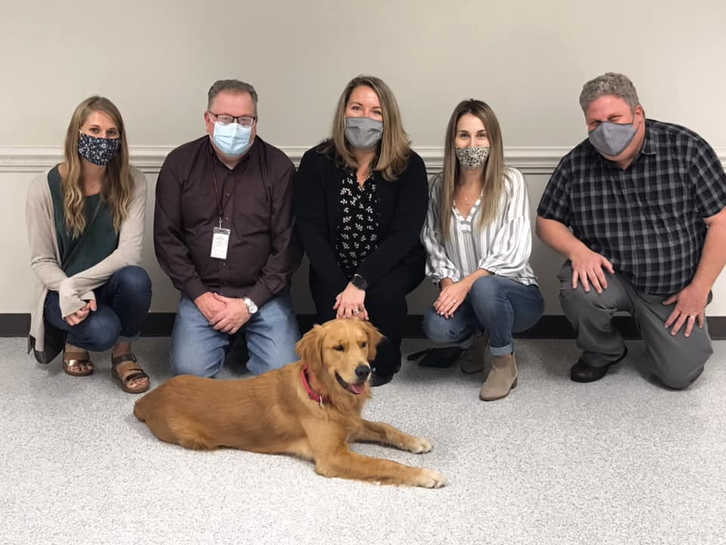

Some EXCITING News from Big Spring School District…

After a two year wait, the District has added a therapy dog, **Lincoln**, to the Big Spring Family! Lincoln has been in training through United Disabilities Services (UDS) for the past several months, and even though he is permanently stationed at the Middle School, your child’s teacher is planning for him to pay a classroom visit in the near future. He will be accompanied by one of his regular handlers from the Middle School.

In an effort to prepare for Lincoln’s visit we want to make sure there are no students in the classroom who possess a severe allergy or fear of dogs. If you have concerns please reach out to our building principal, Mrs. Clarissa Nace. Our learning process around therapy/service dogs over the last two years has been in collaboration with neighboring school districts who currently have therapy/service animals (Mechanicsburg and Northern) to outline our plan to provide for the safe implementation of a service animal program.

There is no need to contact us unless your child has a severe allergy treatment plan or possess a severe fear of dogs.

If you have any additional questions about Lincoln’s visit please feel free to contact your child’s teacher, the building principal or Mrs. Clarissa Nace, Middle School principal at 717-776-2471 and primary handler for Lincoln.

Thanks in advance!

Mrs. Clarissa Nace

Middle School Principal

**Big Spring School District**

[cnace@bigspring.k12.pa.us](mailto:cnace@bigspring.k12.pa.us)

(717) 776-2471